STEPHENS COUNTY APPRAISAL DISTRICT
LOCAL ANNUAL REPORT FOR 2021

The STEPHENS County Appraisal District is a political subdivision of the State of Texas. The provisions of the Texas Property Tax Code govern the legal, statutory, and administrative requirement of the appraisal district. Members of the Board of Directors are elected by the taxing units within the boundaries of STEPHENS County and must live within the district two years prior to serving on the board. The Chief Appraiser is appointed by the Board of Directors and is the chief administrator of the appraisal district. The local taxing units such as your County, School, Cities, Hospital District, and Groundwater Conservation District set a tax rate from your property tax appraisal issued by the Appraisal District. The STEPHENS CAD serves the following taxing units:
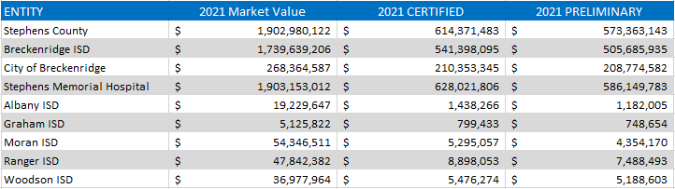
The District maintains approximately 68,606 parcels with property types of residential, commercial, business, utilities, and pipelines. Other school districts are represented in our county such as Albany, Graham, Moran, Ranger and Woodson.

Exemption Data: The district has various exemptions for which taxpayers may qualify, such as the standard residential homestead exemption and the over-65 residential homestead exemption. You may only apply for residence homestead on one property in a tax year. A homestead may include up to 20 acres of land you actually use in the residential use (occupancy) of your home. To qualify for a homestead exemption, you must own and reside in your home on January 1 of the tax year. The age 65 or older or disability exemption for school taxes includes a school tax limitation or ceiling. Some taxing units such as county and cities have exemptions and tax ceilings limits. The filing of this application is between January 1 and April 30. You may file a late homestead exemption if you file it no later than one year after the date taxes become delinquent. There is also a Transfer of Tax Limitation or Ceiling Certificate if you move out of the county. This can transfer to the new county in which you reside.

EXEMPTION DATA
ENTITY | HOMESTEAD | OVER-65 OR DISABLED
STEPHENS COUNTY |  | $ 12,000
BRECKENRIDGE ISD | $ 25,000 | $ 10,000
CITY OF BRECKENRIDGE |  | 3,000

DISABLED VETERANS | AMOUNT | PERCENTAGE
DV1 | $5000 | 10-29%
DV2 | $7500 | 30-49%
DV3 | $10000 | 50-69%
DV4 | $12000 | 70-100%
DVHS | TOTALLY EXEMPT | 100%
*The DVHS applies only to the General Homestead Exemption

2021 TAX RATES PER ENTITY PER $100 OF VALUE
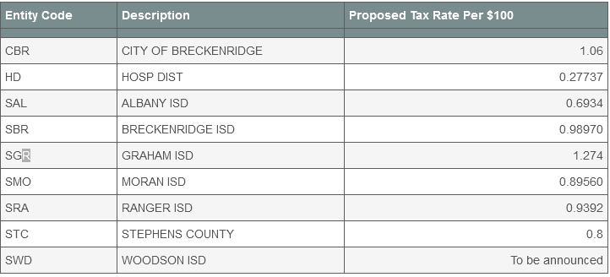

The PROPERTY VALUE STUDY
The property value study is conducted by the State Comptroller’s Office to estimate the taxable property value in each school district and to measure the performance of appraisal districts. If the appraisal district is within a 5% margin of error, the State Comptroller will certify the local value to the Commissioner of Education. The findings of the study are used in the school funding formula for state aid.

